Also do Madsen et al. (2015)

Clark et al. (2013) ch. 9
Three arguments for democracy and economic growth. However, they can all point in different directions.

Property rights:
- Democracy -> rule of law -> stable property rights -> investment -> growth
- Empirical support that property rights lead to growth
- However, is it really true that democracy leads to stable property rights and can dictatorships not also lead to them (Singapore, Lee Kuan Yew), conflicting evidence
- Meltzer-Richard model: democracy does not lead to stable property rights because the state will do lots of redistribution from the mean to the median.
- However, reliance of state on capital and poor people vote less than rich people

Short-termism:
- Workers consume rather than invest.
- For economic development, investment is required. That will be an unpopular policy under democratic regimes so it won’t happen.

Interest-groups, both ways:
- Because dictators are not as pressured by interest groups, they do not have to spend unnecessary resources to keep them happy.
- However, because they are not limited by interest groups, they can more easily behave in a predatory way.

Empirical evidence:
- Graphs are all triangles:
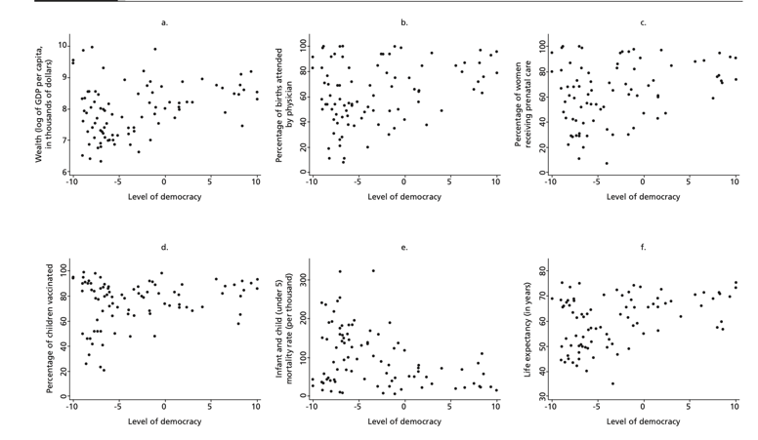
- Democracy is sufficient for economic growth (and other indicators) but not necessary. Depending on the dictatorship, they can also do well, for more discussion of this see chapter 10.

Sen (2000)
Criticizes the false dichotomy between political rights and economic prosperity. He uses three arguments:
- Democracy has intrinsic value: political participation and civil liberties are part of basic human capabilities.
- democracy has instrumental value: elections, opposition parties, and a free press create incentives for governments to respond to citizens’ needs and prevent major disasters. He argues that no substantial famine has ever occurred under democracy.
- democracy has a constructive value: public debate shapes how societies understand and define their needs, including economic priorities.

Democracy is both a means to development and an end in of itself.

Institutionalism

Acemoglu et al. (2014)
Use an IV vavriable: regional change (should be correlated to democracy but not to democratic growth, but that is messy because maybe it does like increase trade etcetera).
They argue that democracy has a causal, sustained effect on economic growth. Using panel data for 175 countries from 1970-2010 they show that democratization increase GDP per capita by around 20% in the long run.
They address 4 methodological problems in the empirical literature:
- measurement error of democracy: they construct a dichotomous measure combining different datasets
- country heterogeneity: they include country and year fixed effects
- GDP-dynamics: using lags they account for the fact that there is usually a big drop in GDP per capita before democratization
- Endogeneity: they control for regional waves of democratization and reversals in neighbouring countries.

They also examine the mechanisms through which democracy increases GDP per capita:
- Raising investment
- Expanding primary education
- Encouraging economic reforms
- Public goods and health outcomes (child mortality)
- Reducing social unrest

Finally, they do not find evidence that democracy in poorer countries harms development. They do find that the effect of democracy is greater in countries with higher education levels.

Papaioannou and Siourounis (2008)
Similar to Acemoglu et al., but different methodology

Rodrik et al. (2004)
Compare institutions, geography and integration (trade openness). They use settler mortality for institutional strength, as it captures how much the Europeans brought their European institutions with them. They find that institutions dominate, geography and trade almost only matter insofar as they influence institutions: tropical disease burden weakens institutional development, trade can improve institutional quality indirectly.

Institutionalism – nuances

Dincecco and Katz (2016)
Argue that it is not limited government (through democracy etc.) but rather state capacity that caused growth from 1650-1913. Fiscal centralization had a very high coefficient, much higher than the limit on the government.

Cox and Weingast (2018)
They argue that horizontal accountability (to the legislature) reduces the economic downturns involved in leadership change, while vertical accountability (to the electorate) does not. Some investments are politically sensitive (depend on stable policies and political connections). If investors expect instability or policy change, they withhold investment. If they expect stability, they invest, reinforcing growth and stability.

They find:
- Leadership turnover significantly reduces economic growth, especially in unconstrained regimes.
- Horizontal executive constraint significantly reduces the size of these downturns.
- Vertical electoral accountability does not significantly reduce succession-related downturns.

In unconstrained regimes, leadership turnover creates major policy and crony uncertainty. Investors pull back, especially from irreversible investments and growth falls. When executives are constrained by legislatures, change is more difficult.

Krieckhaus (2006)
Krieckhaus argues these contradictory findings arise because scholars pool all countries together. In reality, democracy’s impact varies by region. Democracy’s economic effect depends on whether societal pressures or elite behavior dominate in a given region.

Two frameworks:
- Democracy may hurt growth
  - Encourage redistribution
  - Increase government spending
  - Weaken property rights
  - Empower rent-seeking groups
  - More likely when:
    - Inequality is high
    - Social groups demand redistribution
    - Developmental states prioritize industrialization
- Democracy helps growth:
  - Removal of corrupt leaders
  - Accountability
  - Protection against predation
  - More likely when:
    - State elites are corrupt or patrimonial,
    - Authoritarianism shields corrupt leaders.

Krieckhaus derives three region-specific hypotheses:
Latin America
- High inequality → strong redistributive pressures.
- Democracy leads to populism and macroeconomic instability.
- Prediction: Democracy constrains growth.

Asia
- Strong developmental states focused on industrialization.
- Authoritarian regimes insulated technocrats from societal pressures.
- Democracy distracts elites from growth-oriented policy.
- Prediction: Democracy constrains growth.

Sub-Saharan Africa
- Widespread patrimonialism and corruption.
- Authoritarianism protects predatory elites.

- Democracy enables removal of corrupt leaders.
- Prediction: Democracy facilitates growth.

Institutionalism – critiques

Engerman and Sokoloff (2008)
They critique institutionalism:
- Institutions are endogenous: they often emerge in response to initial factor endowments: plantation economies developed restrictive political institutions while more equal settler societies developed broader suffrage.
- No institutional system is necessary for growth, economic growth has occurred under diverse legal systems, banking structures and political regiems.
- Flexibility matters: rigid institutions hurt growth even though the argument usually is that rigidity creates stability which is necessary for investment, they illustrate this with the british example.

On the democracy–growth link, Engerman and Sokoloff stress that the empirical relationship is not straightforward. Democracy may promote growth through broader incentives and property rights, but inequality, elite interests, and institutional design complicate outcomes.

Glaeser et al. (2004)
There are two views:
- Institutions cause growth by securing property rights (North, Acemoglu et al.)
- Human capital causes growth, education and economic development leads to institutional improvement (Lipset, Barro)

They argue:
- Institutional measures are not very good
- Initial human capital (education) strongly predicts subsequent growth. Initial executive constraints do not predict growth
- Critique Acemoglu et al. who use settler mortality and population density in 1500 as substitutes for institutional strength as these are highly related to human capital. European settlers may have brought education and know-how, not merely political institutions.
- Increases in education predict later improvements in institutional quality, institutional measures do not predict later increases in schooling.

Notes

Economic development <-> Democracy
How do you fix the causality:
- Introducing a time component

